Wallace, Jo (notes based on The Forester, published by Institute of Foresters of Australia)
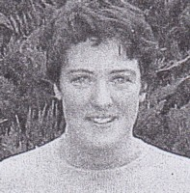
From Victoria. Graduated from Melbourne University in 1995. Worked in Victorian forests for several years. Appointed in Forest Management Branch of W,A. Department of CALM c2002. Involved in work relating to the Regional Forest Agreement, Forest Management Plan 2004-2013, forest inventory, forest disease mapping, growth data etc. Completed a post-graduate degree in economics. Worked in Forest Management Branch for 7 years. Since then has worked in Whiteman Park with the Department of Planning & Infrastructure.

